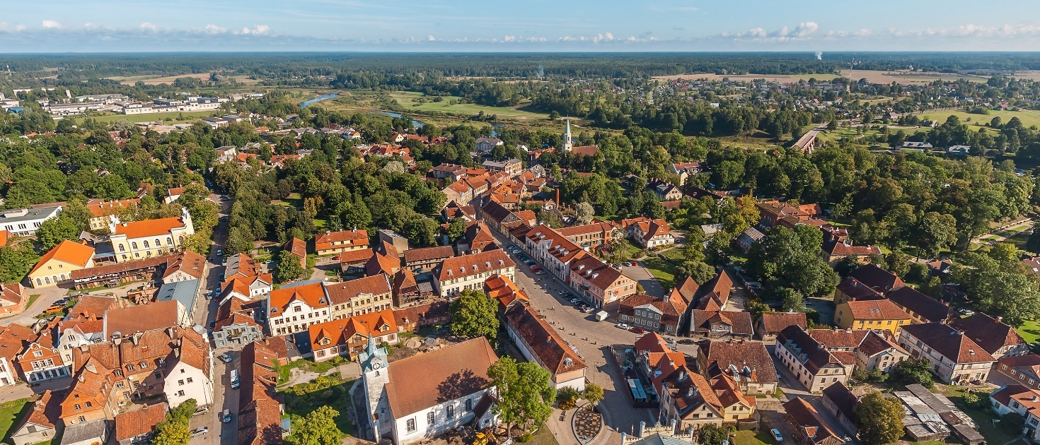

**REGISTRATION FORM**

ANNUAL MEETING AND SCIENTIFIC CONFERENCE - SYMPOSIUM OF THE CIVVIH

**September 10-15** – **Kuldiga - latvia**

**STRATEGIES FOR ENHANCING HISTORIC CITIES’ RESILIENCE**

**TO DISASTERS**

**PARTICIPANT**

LAST NAME:

FIRST NAME:

address:

CITY and COUNTRY:

tel:

EMAIL ADDRESS:

**LANGUAGE(S) SPOKEN:**

FRENCH

ENGLISH

**CIVVIH MEMBER:**

EXPERT MEMBER

ASSOCIATE MEMBER

HONORARY EXPERT MEMBER

**Accompanied by**

LAST NAME:

FIRST NAME:

I WILL ATTEND THE **SCIENTIFIC SYMPOSIUM** **FROM September 11** (ALL day) **to September 12** (Morning)

YES  NO

I WILL ATTEND THE **ANNUAL MEETING** OF THE CIVVIH ON **September 12** (Afternoon)

YES  NO

I will attend THE SCIENTIFIC SYMPOSIUM and the annual meeting **online**

YES  NO

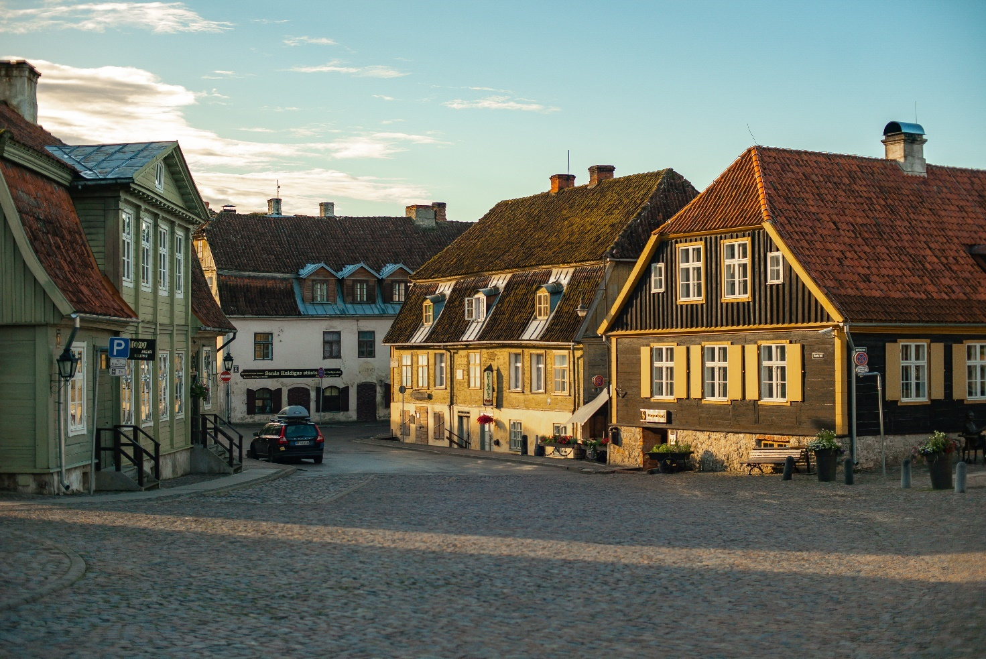

**Post-Symposium Tour**

I WILL PARTICIPATE in the visit ON **September 14** (all day) **to aizpute, talsi and jurmala**

YES  NO

I WILL PARTICIPATE in the visit ON **September 15**(Morning): **guided tour of riga old town**

YES  NO

**dinners**

I WILL PARTICIPATE On **September 11 (Thursday)** to the **welcome Dinner with Municipality Representatives and ICOMOS Latvia (to be confirmed)**

YES  NO

I WILL PARTICIPATE ON **September 12 (Friday)** to the **Dinner in Kuldiga (to be confirmed)**

YES  NO

I WILL PARTICIPATE ON **September 13 (Saturday)** to thE **Late Dinner in Riga (to be confirmed)**

YES  NO

**invitation letter**

I need an invitation letter

YES  NO

**DATE AND HOUR OF YOUR ARRIVAL at AND DEPARTURE** FROM RIGA AIRPORT:

ARRIVAL:  /SEPTEMBER 2025 at ____

DEPARTURE:  /SEPTEMBER 2025 AT ____