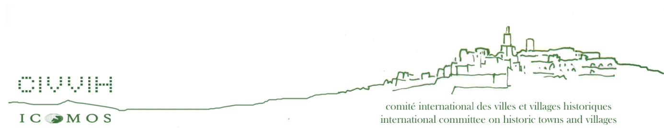

The International Scientific Committee on Historic Towns and Villages ICOMOS-CIVVIH
is pleased to announce the International Conference on

Theory and Practice of Historic Urban Landscape (HUL) and Cities and Sustainable Development (SDG)
October 21-24, 2019, Tunis, Tunisia

PARTICIPATION FORM (please complete In capital letters)
First name………………………………………………………..name……………………………………………………………………
Adress…………………………………………………………………………………………………………………………………………….
……………………………………………………………………………………………………………………………………………………….
City and country…………………………………………………Tel:………………………………………………………………….…
E-mail:……………………………………………………………
Presentation title…………………………………………………………………………………………………………………………
………………………………………………………………………………………………………………………….

Accompanied by:………………………………………………………………………………………………………………………….
Date of arrival……………………………………………………………………
Date of departure…………………………………………………………….

Please send it back until the end of August 2019: Vice-President: Faika Bejaoui; e-mail: fakabejaoui@yahoo.fr, President: Dr. Claus-Peter Echter; email: cpechter@gmx.de

